Paper title goes here: WALLY submission template
Firstname1 Lastname1
York University, Toronto, Canada
Firstname2 Lastname2
University of Toronto, Toronto, Canada
Firstname3 Lastname3
York University, Toronto, Canada
Abstract: Your abstract should be no longer than 150 words. An abstract describes the main purpose, methods, and outcome of your study. It should not contain references as it should be able to stand alone in article indexes like Google Scholar or PsychInfo.
Keywords: style; formatting; linguistics; publishing

Introduction
There are two ways you can use this paper template. You may either follow the instructions detailed in the text below, or you can download the Word version of this document and paste your paper into the template using the styles that are already in place. The main text of your paper should be displayed in “Body Text” style (12 pt Times New Roman, single spaced, first line indentation by 1.27 cm, 6 pt spacing after).

Title and author information
Your paper title should be presented as the first line of the file in the “Title” style (18 pt bold, Times New Roman, with 12 pt spacing after). Only the first word of the title and subtitle should be capitalized. Author name(s) should be listed in the “Authors” style (12 pt, italic, Times New Roman). Affiliations should be presented in the “Affiliations” style (12 pt, italic, Times New Roman, with 6 pt spacing after). The corresponding author should be marked with a footnote (see footnote 1 in this document – 10 pt, italic, Times New Roman) listing their YorkU email address.

Abstract and keywords
The abstract should be introduced by the word “Abstract” followed by a colon. The abstract text should begin immediately after the colon (do not create a new line). The abstract should be presented in “Abstract” style (12 pt, Times New Roman, 2 cm left indentation, 2 cm right indentation, justified, 18 pt spacing before, 12 pt spacing after).
The abstract should be followed by 3 to 7 keywords separated by semicolons and displayed in the “Keyword” style (12 pt, italic, Time New Roman, 2 cm left indentation, 2 cm right indentation, justified, 12 pt spacing before, 24 pt spacing after). Keywords describe the main content of the research and can be used to find your paper in a Google search (e.g., discourse analysis; language and law; computer-mediated communication).

Headings
You may use up to 4 levels of nested headings. All headings must be numbered as described in section 2.1. The first level of heading should appear in “Heading 1” style (12 pt, bold, Times New Roman, centred, 6 pt spacing before). Heading 2 should be displayed in “Heading 2” style (12 pt, bold, Times New Roman, left justified, 6 pt spacing before). Heading 3 should be displayed in “Heading 3” style (12 pt, bold, italic, Times New Roman, left justified, 6 pt spacing before). Heading 4 should be displayed in “Heading 4” style (12 pt, italic, Times New Roman, left justified, 6 pt spacing before). For all levels of headings only the first word in the heading should be capitalized.

Numbering your headings
If you use the styles already available in the document, numbering will occur automatically. Otherwise, sections should be numbered with decimal places as shown below:
- Heading level 1 - # - e.g. 1
- Heading level 2 - #.# - e.g. 1.1
- Heading level 3 - #.#.# - e.g. 1.1.1
- Heading level 4 - #.#.#.# - e.g. 1.1.1.1
Do not put a period after the final number in the section number. Do not use headings below the 4th level.

Nesting your headings
When nesting headings within each other, please ensure that the lower level heading is a subtopic of the higher level heading. If the new heading is not a subtopic of the previous but is a subtopic of a single shared heading, start a new set of headings at the same level as the previous heading. If the two headings do not share a common higher level heading, start a brand new set of headings at level 1. See below for an example.

Methodology

Experiment 1

Participants (for experiment 1)

Procedure (for experiment 1)

Stimuli (used in procedure for experiment 1)

Experiment 2

Participants (for experiment 2)

Procedure (for experiment 2)

Stimuli (used in procedure for experiment 2)

Results

And another subsection.

Figures and Tables
All figures and tables must be referred to in text and should be displayed either immediately before or after the paragraph in which they are first referred to.

Figures
Please include figures in your text AND submit each figure as an individual file. Figure files should be JPEG files that are at least 500px wide and 100px tall. Figures also include charts. If you have charts imported from Excel, you must either save them as a JPEG file to submit separately, or you must submit an Excel file that includes the chart as well as all of the data used in the chart. All figures must be created by the author. If you are using figures from another source, you must contact the editors before submission.
All figures must be numbered and accompanied by a descriptive caption. The caption serves as the ‘title’ of your figure and hence should not exceed three lines long. Captions should be placed below the figure and displayed in the “Figure Caption” style (12 pt, Times New Roman, centred, with 2 pt spacing before and 12 pt spacing after). The caption should begin with “Figure #.” as shown in Figure 1, below.

Accessibility concerns
Figures should have alt text assigned. This can be done through the Picture Format pane in Word. Alt text should be one to two sentences long and should provide a clear description of what is visible in the figure. Because alt text cannot always fully describe a figure, please also ensure that any important information displayed in a figure is also communicated in text. Please also note that figures should not rely exclusively on colour to communicate information. To check this, please view your figures in black and white and ensure that all of the information you intend to convey is still communicated by the colourless version of the figure.
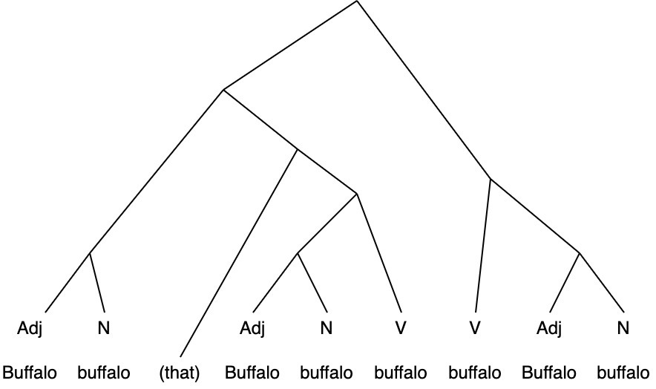
Figure 1. This is a figure caption for the buffalo tree.

Tables
Tables may be used to display numerical and textual data. Tables should be editable and included in text. Horizontal lines may be used. Vertical lines should not be used (as shown in Table 1, below).
Table 1. This is a table title.
 | Column header | Column header | Column header
Row title | 2 | 4.23 | Yes
Row title | 1 | 6.00 | No

All tables must be numbered and titled in “Table Title” style (12 pt, Times New Roman, justified, with 12 pt spacing before and 2 pt spacing after). Table titles should be placed above the table and should begin with “Table #.” as shown in Table 1, above. Titles should not exceed 2 lines in length. Tables should be followed by one blank line in “Body Text” style.

Examples
Here we account for a variety of different examples that may be included in your work. If you’d like to include an example that isn’t described here, please contact the editors.
All examples included in your work should be editable. Examples must be numbered with the numbers enclosed by round brackets (numbers should be aligned left at 1.27 cm with a 1.9 cm indent). If you use the “Example” style this numbering will happen automatically.

Basic examples (e.g., syntax, semantics)
Examples which are not taken from transcripts and are not in non-English languages may simply be displayed in “Example” style (12 pt, Times New Roman, justified, with 0 pt spacing before and 2 pt spacing after; numbering in round brackets, aligned left at 1.27 cm with a 1.9 cm indent). If providing multiple sub examples within a single example, please tab in each new sub example so that it is displayed with lettering in round brackets (if not using the preset style, please format lettering to align left at 1.9 cm with a 2.54 cm indent). If proceeding to an additional level of sub examples, please tab in twice to display with Roman numerals in round brackets (if not using the preset style, please format lettering to align left at 2.54 cm with a 3.17 cm indent). All examples should be followed by one blank line in “Body Text” style. See examples (1-3) below. Examples should be cited in text as follows: Example (1) shows a basic example.
- This is a basic example

- This is a more complex example.
  - This sentence is grammatical
  - *Ungrammatical sentence the is

- This is the most complex example
  - Example
    - Example
    - Example
  - Example
    - Example

Non-English examples
Non-English examples should be presented with an interlinear (grammatical) gloss and an English gloss/translation. The non-English example should be presented in “Example” style (12 pt, Times New Roman, justified, with 0 pt spacing before and 2 pt spacing after; numbering in round brackets, aligned left at 1.27 cm with a 1.9 cm indent).
Interlinear glossing should be presented in “Interlinear Gloss” style (12 pt, Times New Roman, justified, with first line indentation of 1.9 cm, 2 pt spacing after) in the line immediately below the non-English example. All grammatical abbreviations used in the interlinear gloss must be in small caps.
Abbreviations for grammatical terms used in interlinear glosses can be found here: https://en.wikipedia.org/wiki/List_of_glossing_abbreviations
English glosses should be presented in “English Gloss” style (12 pt, italic, Times New Roman, justified, with first line indentation at 1.9 cm and 2 pt spacing after) in the line immediately below the interlinear gloss. See Example (4), below.
- Je ne sais pas
I neg know-pres neg
I don’t know

Conversation/Discourse Analysis examples from transcripts
When citing multiple lines from a transcript, please use the “Example” style (12 pt, Times New Roman, justified, with 0 pt spacing before and 2 pt spacing after; numbering in round brackets, aligned left at 1.27 cm with a 1.9 cm indent) to title and provide line/source reference for your example. You may continue to use the Example style to present your extract. If you are presenting conversation analysis materials or other transcripts with multiple speakers, please use the “Transcripts” style (10 pt, Courier New, justified, with left indentation of 2 cm and 2 pt spacing after) to display the actual example text.
All lines in the transcript should be numbered such that the number of digits in each line number is equal to the number of digits in the longest line number cited in the paper. E.g., If the highest line number is 105, line number 1, should be prefaced by two 0s (i.e., 001). A single space should be included between the line number and the example text.
If transcripts are in a non-English language, please contact the editors for guidance.
- Put your transcribed data title and line/source references here
0900 text goes here
0901 text goes here

Footnotes
Footnotes should be kept to a minimum, as all relevant information should be included in your text. If footnotes are included, they may be created using the Word automatic “Insert Footnotes” tool. Footnotes should be numbered using Arabic numerals (i.e., 1,2,3,4…) and should be placed after punctuation marks. If using software other than Word, please note that footnotes should be displayed on the same page as the insertion point and should be displayed in 10pt, Times New Roman font, as in the example below here. Footnotes should not be used for citation information.

In-text citations
Any time you refer to another publication whether directly or paraphrasing, you must include an in-text citation. In-text citations should be displayed in APA Style (7th Edition) as shown in the example here (Author, 2020). When presenting a direct quote or a close paraphrase, the page number that the quote or paraphrase was drawn from must be included in the in-text citation as shown in the example here: (Author, 2020, p. 1). If you quote directly from the text and the quote does not exceed 40 words, it should be enclosed in double quotation marks.
If you quote directly from a text and your quote exceeds 40 words in length, please use the “Block Quotes” style (12 pt, Times New Roman, justified, with a left indentation of 1.27 cm, with 6 pt spacing after). Be sure to include your in-text citation after the final punctuation mark in the block quote. (Author, 2020, p. 30)
The text immediately following a block quote should not be indented. See link in References List section for additional guidance. On the presentation of in-text citations.
Acknowledgements
Should you wish to thank any person or (funding) organization for their support or assistance with your paper, you may include an acknowledgements section directly preceding the References List. Please begin the section with the heading Acknowledgements in “Acknowledgements Heading” style (12 pt, bold, Times New Roman, centered, with 6 pt spacing before). The text of the acknowledgements should be displayed in “Body Text” style.
References
All references cited in text must be included in the references list. Your reference list should begin with the heading References in “References Heading” style (12 pt, bold, Times New Roman, centered, with 6 pt spacing before). All references should be in “References” style (12 pt, Times New Roman, justified, with a hanging indent of 1.27 cm) and should be formatted in accordance with APA Style (7th Edition) as in the templates below. OWL Purdue provides additional examples and guidance for citing other types of materials: https://owl.purdue.edu/owl/research_and_citation/apa_style/apa_style_introduction.html. You are also encouraged to use automatic referencing software where appropriate.
Author, A. A., & Author, B. B. (2001). Title of chapter. In E. E. Editor & F. F. Editor (Eds.), Title of work: Capital letter also for subtitle (pp. pages of chapter). Publisher. DOI (if available)
Author, A. A., Author, B. B., & Author, C. C. (2005). Title of article. Title of Periodical, volume number(issue number), pages. https://doi.org/xx.xxx/yyyy
Author, A. B. (2020). Title of work: Capital letter also for subtitle. Publisher Name. DOI (if available)
Author, B. B. (2019, August). Title of article. Title of Newspaper, pages.
Author, E. E. (Year, Month Date). Title of page. Site name. URL
Editor, E. E. (Ed.). (1990). Title of work: Capital letter also for subtitle. Publisher. DOI (if available)
Appendix A: Title your appendix here
If you wish to provide any additional material as appendices, you may include it after the references list. Each appendix must be headed by a title in “Appendix Heading” style (12 pt, bold, Times New Roman, centered, with 6 pt spacing before). Name each appendix you include consecutively by letter of the alphabet, followed by a colon and then a descriptive title, e.g., “Appendix A: Transcription conventions”, “Appendix B: Survey instrument”.

Corresponding Author: email@(my.)yorku.ca (note: the corresponding author must be a York student or employee)
This is a footnote.

