Paper Title Goes Here: WALLY Submission Template
Firstname1 Lastname1
York University, Toronto, Canada
Firstname2 Lastname2
University of Toronto, Toronto, Canada
Firstname3 Lastname3
University Affiliation
Abstract: Your abstract should be no longer than 150 words. Elements to include in your abstract may include key aspects of your literature review; the problem, hypothesis, or research question under investigation; your methods or methodology; the main results or findings; and any implications of your paper. It should not contain references as it should be able to stand alone in article indexes like Google Scholar or OMNI.
Keywords: style; formatting; linguistics; publishing

Introduction
This template primarily provides detailed information about structural and formatting expectations as pertaining to WALLY. You may use it as a reference to answer formatting questions as they come up, follow the instructions detailed in the text below step-by-step, or download the Word version of this document and paste the content of your manuscript into the template using the styles that are already in place. Please note that if there are many issues with formatting, your manuscript may be returned to you with revision requests before it can be accepted.

General Formatting and Style Considerations
In general, WALLY’s primary concerns regarding formatting are consistency and clarity. For these reasons, we use a combination of APA 7th edition guidelines (American Psychological Association, 2024c) and guidelines that are unique to our journal. For example, in APA 7th edition style, ordinal suffixes (e.g., -st, -nd, -rd, -th) may be superscripted or not (i.e., 7th or 7th); however, please note that your paper should choose one option and use it consistently throughout (Purdue Online Writing Lab, n.d.-c). Similarly, while both American and British spellings are generally acceptable in Canadian English, your paper should consistently use either American or British spelling conventions throughout.
The majority of your manuscript (unless specified otherwise in the sections below) should be displayed in “Body Text” style (justified text alignment, 12 pt, Times New Roman, single-spaced, first line indentation by 1.27 cm, 6 pt spacing after). To apply the styles in this template, access the Styles pane by navigating to Home > Styles and clicking the dialogue box arrow (or use the keyboard shortcut Alt + Ctrl + Shift + S), then click on a style to apply it.

Title, Author Information, and Recommended Citation
Your paper title should be presented as the first line of the file in the “Title” style (18 pt, bold, Times New Roman, 12 pt spacing after). The title should use title case, meaning all major words should be capitalized. Author name(s) should be listed in the “Authors” style (12 pt, italic, Times New Roman). Affiliations should be presented in the “Affiliations” style (12 pt, italic, Times New Roman, 6 pt spacing after). The corresponding author must be a York University student and marked with a footnote (see Footnote 1 in this document—10 pt, Times New Roman) listing their corresponding email address (preferably their YorkU email, though an alternative email address is acceptable, particularly if they have already graduated or will graduate from York University soon). A recommended citation in APA 7th edition will also be included in the footnote under the corresponding author. Please note that a DOI will be generated upon scheduling your work for publication and will be added by the editors prior to publishing. It will not appear on any proof prior to publication.

Abstract and Keywords
The abstract should be introduced by the word “Abstract” followed by a colon. The abstract text should begin immediately after the colon (do not create a new line). The abstract should be presented in “Abstract” style (12 pt, Times New Roman, 2 cm left indentation, 2 cm right indentation, justified, 18 pt spacing before, 12 pt spacing after).
The abstract should be followed by three to seven keywords separated by semicolons and displayed in the “Keywords” style (12 pt, italic, Times New Roman, 2 cm left indentation, 2 cm right indentation, justified, 12 pt spacing before, 24 pt spacing after). Keywords describe the main content of the research and can be used to find your paper in a Google search (e.g., discourse analysis; language and law; computer-mediated communication). Keywords can include paper elements related to the research topic, theoretical framework(s), population, method or methodology, and applications and/or implications of results and findings.

Headings
You may use nested headings following APA 7th edition guidelines (American Psychological Association, 2022). Use title case for all levels of headings, which includes capitalizing all major words. All headings must be numbered as described in Section 2.1. The first level of heading should appear in “Heading 1” style (12 pt, bold, Times New Roman, centered, 6 pt spacing after). Heading 2 should be displayed in “Heading 2” style (12 pt, bold, Times New Roman, left-aligned, 6 pt spacing after). Heading 3 should be displayed in “Heading 3” style (12 pt, bold, italic, Times New Roman, left-aligned, 6 pt spacing after). Heading 4 should be displayed in “Heading 4” style (12 pt, bold, Times New Roman, left-aligned, first line indentation by 1.27 cm, 6 pt spacing after). Heading 5 should be displayed in “Heading 5” style (12 pt, bold, italic, Times New Roman, left-aligned, first line indentation by 1.27 cm, 6 pt spacing after). For any other level of heading, please consult with the editors.

Numbering Your Headings
If you use the styles already available in the document, numbering will occur automatically. Otherwise, sections should be numbered with periods as shown below:
- Heading Level 1 - # - e.g., 1
- Heading Level 2 - #.# - e.g., 1.1
- Heading Level 3 - #.#.# - e.g., 1.1.1
- Heading Level 4 - #.#.#.# - e.g., 1.1.1.1
- Heading Level 5 - #.#.#.#.# - e.g., 1.1.1.1.1
Do not put a period after the final number in the section number.

Nesting Your Headings
When nesting headings within each other, please ensure that the lower-level heading is a subtopic of the higher-level heading. If the new heading is not a subtopic of the previous but is a subtopic of a single shared heading, start a new set of headings at the same level as the previous heading. If the two headings do not share a common higher-level heading, start a brand-new set of headings at level 1. See below for general and specific examples.

Methodology

General Example Subheading
Paragraphs start here.

Related Subtopic 1
Paragraphs start here.

More Specific Subtopic Related to Subtopic 1.
Paragraphs start here.

Even More Specific Subtopic Related to Subtopic 1.
Paragraphs start here.

Experiment Methods (Specific Example)
Description of experiment methods begins here.

Participants (for Your Experiment)
Description of participants for experiment begins here.

Procedure (for Your Experiment)
Description of procedure for experiment begins here.

Stimuli (for Your Experiment).
Description of stimuli begins here.

Results

And Another Subsection

Figures and Tables
Figures and tables must be referred to in text using their number (e.g., “Figure 1” or “Table 1” for figures and tables in text, “Figure/Table A1,” “Figure/Table A2,” or “Figure/Table B1” for figures and tables in appendices). All figures and tables in the body of the paper should immediately follow their mention while also meeting the following requirements: 1) they must be located only at the top or bottom of a page, and 2) all components of the figure or table (number, title, image or table body, optional legend, and optional note) must be on the same page. All essential figures and tables should be presented in the body of the paper, while all supplemental information (including supplemental figures and tables) should be presented in appendices. Examples of supplemental information may include transcription conventions; raw data; detailed information about an intervention, lesson, course, or syllabus; or other information that authors may wish to include but may be too bulky, interrupt the flow of the text, or not be immediately necessary to fully appreciate and understand the information in the text.

Tables
Tables are unique visual displays that use rows and columns to display numerical and/or textual information. All tables must follow APA 7th edition guidelines (American Psychological Association, 2021b). Tables should be editable and included in text (i.e., not included as a screenshot or image). Horizontal lines may be used. Vertical lines should not be used, but there should be enough space between columns to make them clear and easy to follow.
All tables must be numbered and titled in the order in which they appear. The table number should be presented in “Table Number” style (12 pt, bold, Times New Roman, left-aligned) and located above the table. The table title should use title case (all major words capitalized) and be presented in “Table Title” style (12 pt, italic, Times New Roman, justified), and located below the number but above the table. Titles should be brief but descriptive. Text within the table should be presented in “Table Text” style (12 pt, Times New Roman, either centered or left-aligned as needed for readability, 3 pt spacing before and after). Optional table notes should be presented in “Table Note” style (12 pt, Times New Roman, justified), introduced with the word “Note” in italics followed by a period. See Table 1 as an example.

Figures
Please include figures (any visual displays that are not tables) in your paper and as individual files in your submission. Figure files should be JPEG files that are at least 500px wide and 100px tall, and any images should use high-contrast colors whenever possible. For accessibility, please also note that figures should not rely exclusively on color to communicate information. Please view your figures in black and white and ensure that all of the information you intend to convey is still communicated by the colorless version of the figure. Figures also include charts. If you have charts imported from Excel, you must either save them as a JPEG file to submit separately, or you must submit an Excel file that includes the chart as well as all the data used in the chart. All figures must be created by the author or used with permission. If you are using figures from another source, you must contact the editors before submission.
Figures must have alt text assigned, which can be done through the Picture Format tab in
Table 1
Table Title Goes Here with Major Words Capitalized
 | Column header | Column header | Column header
Row title | 2 | 4.23 | Yes
Row title | 1 | 6.00 | No
Note. This is an optional note.
Word. Alt text is an easy but necessary measure that helps increase accessibility. All instances of alt text should provide a clear description of the figure while also being as concise as possible. While not meant to describe every detail of a figure or image, it should include the most relevant details (which typically includes all written text, since it would not otherwise be accessible). Finally, you should ensure that any important information displayed in a figure is also communicated in text, especially as it relates to the content of your manuscript.
All figures must be numbered and titled in the order in which they appear. The figure number should be presented in “Figure Number” style (12 pt, bold, Times New Roman, left-aligned) and located above the figure. The figure title should use title case (all major words capitalized) and be presented in “Figure Title” style (12 pt, italic, Times New Roman, justified), and located below the number but above the figure. The figure itself should be presented in “Figure Image” style (centered, 6 pt spacing after). Optional components include a legend within the figure or a note below the figure providing a description. Optional figure notes should be presented in “Figure Note” style (12 pt, Times New Roman, justified), introduced with the word “Note” in italics followed by a period. Figure 1 is one example that includes most potential components.

Other Considerations for All Tables and Figures
All tables and figures must follow APA 7th edition guidelines (American Psychological Association, 2021a, 2021b), with an exception related to spacing: all text components other than those in the “Table Text” style should use the same “Body Text” spacing as the rest of the document (12 pt, Times New Roman, 6 pt spacing after). Avoid using “above” or “below” to reference figures or tables as readers may print your work or have multiple pages visible side-by-side at the same time. If a figure or table is at the top of a page, include an extra line after it and
Figure 1
Syntax Tree of a Sentence Using the Word “Buffalo”
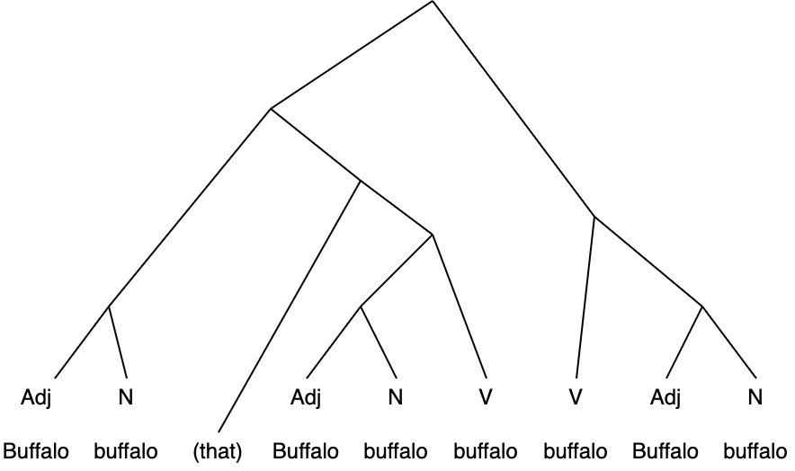
Note. This is an optional note.
before the following text; if a figure or table is at the bottom of a page, no extra line is necessary, as the “Body Text” style is already set to have 6 pt spacing after. Also include an extra line between two figures or tables that appear back-to-back. Extra lines should be in “Body Text” style. Wherever possible, the overall pagination and positioning of figures and tables should be such that there is minimal white space. If your table or figure includes text in a language other than English, a clear, easy-to-follow translation of the relevant text must be included. For clarity, please indicate the source of the translation in the note (e.g., the author, a translation engine, etc.). See Figures A1, A2, and A3 as potential examples of how to clearly indicate which text in a figure is being translated.

Examples
Here we account for a variety of different examples that may be included in your work. If you’d like to include an example that isn’t described here, please consult with the editors. All examples included in your work should be editable. Examples must be numbered with the numbers enclosed by round brackets (numbers should be aligned left at 1.27 cm with a 1.9 cm indent). If you use the “Example” style, this numbering will happen automatically.

Basic Examples (e.g., Syntax, Semantics)
Examples which are not taken from transcripts and are not in non-English languages may simply be displayed in “Example” style (12 pt, Times New Roman, justified, 0 pt spacing before and 2 pt spacing after; numbering in round brackets, aligned left at 1.27 cm with a 1.9 cm indent). If providing multiple sub-examples within a single example, please tab in each new sub-example so that it is displayed with lettering in round brackets (if not using the preset style, please format lettering to align left at 1.9 cm with a 2.54 cm indent). If proceeding to an additional level of sub-examples, please tab in twice to display with Roman numerals in round brackets (if not using the preset style, please format lettering to align left at 2.54 cm with a 3.17 cm indent). All examples should be followed by one blank line in “Body Text” style. See Examples (1–3) below. Examples should be cited in text as follows: Example (1) shows a basic example.
- This is a basic example

- This is a more complex example
  - This sentence is grammatical
  - *Ungrammatical sentence the is

- This is the most complex example
  - Example
    - Example
    - Example
  - Example
    - Example

In-text Non-English Examples
In-text non-English examples should be presented with an interlinear (grammatical) gloss and an English gloss/translation. The non-English example should be presented in “Example” style (12 pt, Times New Roman, justified, 0 pt spacing before and 2 pt spacing after; numbering in round brackets, aligned left at 1.27 cm with a 1.9 cm indent).
Interlinear glossing should be presented in “Interlinear Gloss” style (12 pt, Times New Roman, justified, first line indentation by 1.9 cm, 2 pt spacing after) in the line immediately below the non-English example. For clarity and readability, each word in the interlinear gloss should be left-aligned with each word in the corresponding example, as in Example (4), below. Where extra spacing between words is necessary for proper alignment, please avoid typing multiple spaces in a row and instead use tab stops (i.e., press the tab key as many times as needed). This ensures that formatting remains consistent across file conversions and document viewers. All grammatical abbreviations used in the interlinear gloss must be in small caps. Abbreviations for grammatical terms used in interlinear glosses may be found on Wikipedia (List of glossing abbreviations, 2025).
English glosses should be presented in “English Gloss” style (12 pt, italic, Times New Roman, justified, first line indentation by 1.9 cm, 2 pt spacing after) in the line immediately below the interlinear gloss. See Example (4), below. As with basic examples, non-English examples should be followed by one blank line in “Body Text” style.
- Je ne sais pas
I neg know.pres neg
I don’t know

Conversation/Discourse Analysis Examples from Transcripts
When citing multiple lines from a transcript, please use the “Example” style (12 pt, Times New Roman, justified, 0 pt spacing before and 2 pt spacing after; numbering in round brackets, aligned left at 1.27 cm with a 1.9 cm indent) to title and provide line/source references for your example. You may continue to use the “Example” style to present your extract. If you are presenting conversation analysis materials or other transcripts with multiple speakers, please use the “Transcripts” style (10 pt, Courier New, justified, 1.27 cm left indentation, 2 pt spacing after) to display the actual example text.
All lines in the transcript should be numbered such that the number of digits in each line number is equal to the number of digits in the longest line number cited in the paper. E.g., if the highest line number is 105, line number 1 should be prefaced by two 0s (i.e., 001). A single space should be included between the line number and the example text. Transcripts should be followed by one blank line in “Body Text” style.
If transcripts are in a non-English language, please contact the editors for guidance.
- Put your transcribed data title and line/source references here
0900 text goes here
0901 text goes here

Footnotes
Footnotes should be kept to a minimum, as all relevant information should be included in your text. APA provides information on two types of footnotes: content and copyright (Purdue Online Writing Lab, n.d.-b). Content footnotes may provide supplemental information for readers or point them in the direction of where to find more detailed information. Copyright footnotes are used to provide citations for unique situations, such as cases where more than 500 words of a previously published source are reproduced or a figure or table has been reproduced (which can only be done with written, formal permission of the original author or publisher or through special agreements made between York University and select publishers). Footnotes should not be used for any other citation information. If you are unsure if any aspect of your work meets these criteria, please consult with the editors.
If footnotes are included, they should be created automatically using the Word “Insert Footnotes” tool under the “References” tab. Footnotes should be numbered using Arabic numerals (i.e., 1, 2, 3, 4…) and should be placed after punctuation marks. If using software other than Word, please note that footnotes should be displayed on the same page as the insertion point and should be displayed in 10 pt, Times New Roman font, as in the example below here.

In-text Citations
Any time you refer to another publication whether directly or paraphrasing, you must include an in-text citation. In-text citations should be displayed following APA 7th edition guidelines (American Psychological Association, 2024b) as shown in the example here (Author, Year). When presenting a direct quote or a close paraphrase, the page number that the quote or paraphrase was drawn from must be included in the in-text citation as shown in the example here (Author, Year, p. #). If you quote directly from the text and the quote does not exceed 40 words, it should be enclosed in double quotation marks.
If you quote directly from a text and your quote exceeds 40 words in length, please use the “Block Quote” style (12 pt, Times New Roman, justified, 1.27 cm left indentation, 6 pt spacing after). Be sure to include your in-text citation after the final punctuation mark in the block quote. (Author, Year, p. #)
If the text following a block quote is part of the same idea, explanation, or paragraph, it should not be indented. See the link in the “References” section for additional guidance on the presentation of in-text citations.

Acknowledgements
Should you wish to thank any person or (funding) organization for their support or assistance with your paper, you may include an acknowledgements section directly preceding the reference list. Please begin the section with the heading “Acknowledgements” in “Non-Numbered Headings” style (12 pt, bold, Times New Roman, centered, 6 pt spacing after). The text of the acknowledgements should be displayed in “Body Text” style.

References
All references cited in text must be included in the reference list. Your reference list should begin immediately after the last section of your paper (i.e., the “References” section does not begin on its own page) with the heading “References” in “Non-Numbered Headings” style (12 pt, bold, Times New Roman, centered, 6 pt spacing after). All references should be in “References” style (12 pt, Times New Roman, justified, with a hanging indent of 1.27 cm) and should be formatted following APA 7th edition guidelines (American Psychological Association, 2023). Some examples have been included below, along with all citations used in this template. Purdue OWL provides additional examples and guidance for citing other types of materials (Purdue Online Writing Lab, n.d.-a). You may also use automatic referencing software where appropriate.

American Psychological Association. (2021a). Figure setup. Retrieved November 15, 2025, from https://apastyle.apa.org/style-grammar-guidelines/tables-figures/figures
American Psychological Association. (2021b). Table setup. Retrieved November 15, 2025, from https://apastyle.apa.org/style-grammar-guidelines/tables-figures/tables
American Psychological Association. (2022). Headings. Retrieved November 15, 2025, from https://apastyle.apa.org/style-grammar-guidelines/paper-format/headings
American Psychological Association. (2023). References. Retrieved November 15, 2025, from https://apastyle.apa.org/style-grammar-guidelines/references
American Psychological Association. (2024a). Appendices setup. Retrieved November 15, 2025, from https://apastyle.apa.org/style-grammar-guidelines/paper-format/appendices
American Psychological Association. (2024b). In-text citations. Retrieved November 15, 2025, from https://apastyle.apa.org/style-grammar-guidelines/citations
American Psychological Association. (2024c). Style and grammar guidelines. Retrieved November 15, 2025, from https://apastyle.apa.org/style-grammar-guidelines
Author, A. A., & Author, B. B. (Year). Title of chapter. In E. E. Editor & F. F. Editor (Eds.), Title of book: Capital letter also for subtitle (pp. #–#). Publisher. DOI (if available)
Author, A. A., Author, B. B., & Author, C. C. (Year). Title of article. Title of Periodical, volume number(issue number), pages. https://doi.org/xx.xxx/yyyy
Author, A. B. (Year). Title of book: Capital letter also for subtitle. Publisher Name. DOI (if available)
Author, B. B. (Year, Month Day). Title of news article. Title of Newspaper, page(s). URL
Author, E. E. / Group Name. (Year, Month Day). Title of webpage. Site Name. URL
Editor, E. E. (Ed.). (Year). Title of work: Capital letter also for subtitle. Publisher. DOI (if available)
Government of Canada. (2025, September 19). Alternative text and long description – Best practices. Retrieved November 19, 2025, from https://a11y.canada.ca/en/alternative-text-and-long-description-best-practices/
Harvard University. (n.d.). Write helpful alt text to describe images. Retrieved November 19, 2025, from https://accessibility.huit.harvard.edu/describe-content-images
List of glossing abbreviations. (2025, November 5). In Wikipedia. https://en.wikipedia.org/wiki/List_of_glossing_abbreviations
Purdue Online Writing Lab. (n.d.-a). APA style introduction. Retrieved November 15, 2025, from https://owl.purdue.edu/owl/research_and_citation/apa_style/apa_style_introduction.html
Purdue Online Writing Lab. (n.d.-b). Footnotes and endnotes. Retrieved November 15, 2025, from https://owl.purdue.edu/owl/research_and_citation/apa6_style/apa_formatting_and_style_guide/footnotes_and_endnotes.html
Purdue Online Writing Lab. (n.d.-c). Numbers & statistics. Retrieved March 2, 2026, from https://owl.purdue.edu/owl/research_and_citation/apa_style/apa_formatting_and_style_guide/apa_numbers_statistics.html

Appendix

Title of Your Appendix Here
If you wish to provide additional material as appendices, any appendix must follow APA 7th edition guidelines (American Psychological Association, 2024a). Appendices must come after the references, and each appendix should begin on its own page. The first page of the appendix must be headed by an appendix label in “Non-Numbered Headings” style (12 pt, bold, Times New Roman, centered, 6 pt spacing after). If you include multiple appendices, label each appendix you include consecutively by letter of the alphabet (e.g., “Appendix A,” “Appendix B,” etc.). The title of the appendix should be short but descriptive (e.g., “Transcription Conventions”; “Survey Instrument”), appear below the appendix label, use title case, and also follow the “Non-Numbered Headings” style.
Figure A1
Example of a Figure with a Language other than English: Highlights
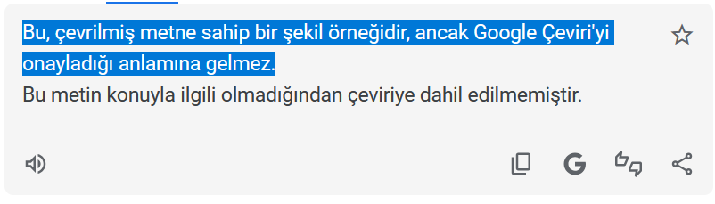
Note. Highlighted text reads, “This is an example of a figure with translated text, but it is not an endorsement of Google Translate.” Translation provided by the author.

Figure A2
Example of a Figure with a Language other than English: Line Numbers
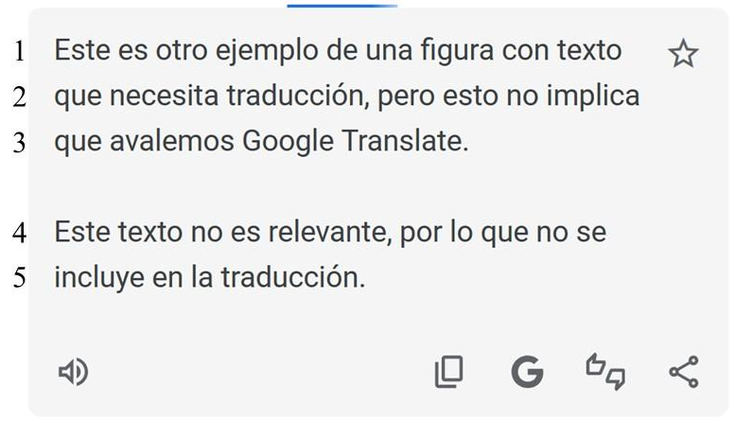
Note. Lines 1–3 read, “This is another example of a figure with text that needs to be translated, but it is still not an endorsement of Google Translate.” Translation provided by the author.

Figure A3
Example of a Figure with a Language other than English: Side-by-side Translation
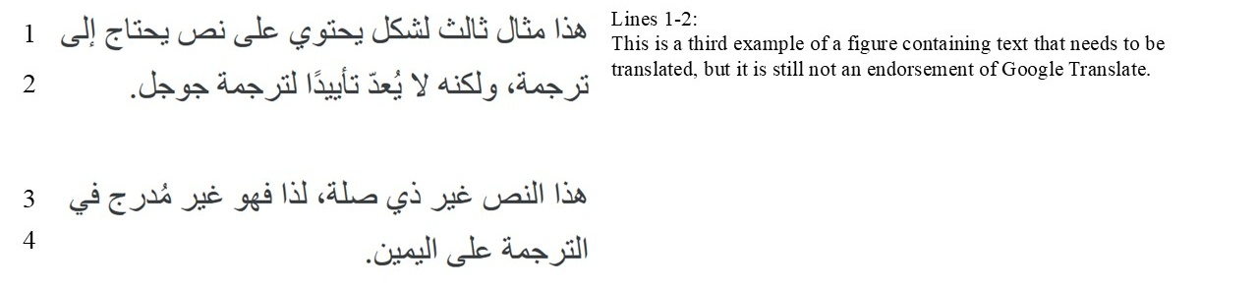

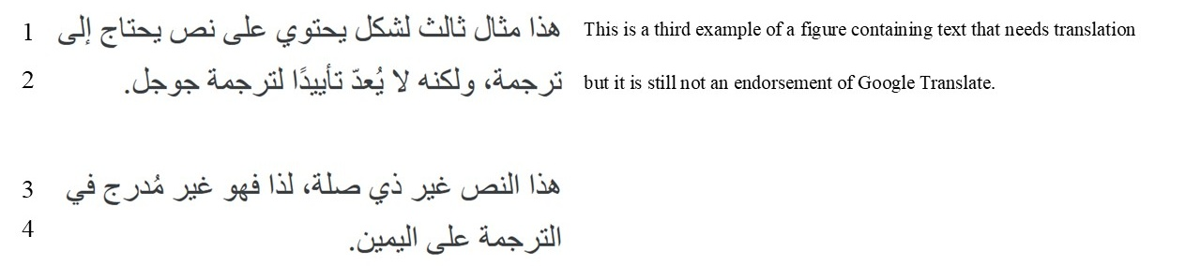
Note. This option is not preferred as the translation is small and difficult to read. You may combine these options however you see fit, but you should prioritize making the translation, and whichever part of the image is translated, clear and easy to follow.

Corresponding Author: email@(my.)yorku.ca Recommended Citation: Lastname1, A. A., Lastname2, B. B., & Lastname3, C. C. (Year). Paper title goes here: WALLY submission template. Working papers in Applied Linguistics and Linguistics at York, Vol #, p.–p. DOI added upon publication
For more information on alt text, see guidance provided by the Government of Canada (2025) or Harvard University (n.d.) in the references.
This is a footnote.

